Over time restorations need to be replaced due to wear-and-tear and other factors. On average, composite and amalgam restorations range of ideal condition before distortion and deterioration sets in is 10 to 15 years.
Many older adults still have their amalgam restorations that were placed since their teenage years. Although the restorations are still in place, it does not mean that they are still in good condition. Over time, given the intrinsic nature of the material and the local environmental stresses (e.g., brushing too hard, acidic foods, grinding your teeth, etc.) the amalgam restoration begins to corrode and distort, leading to stress fractures and part of the tooth chipping away, along with a risk for recurrent decay.
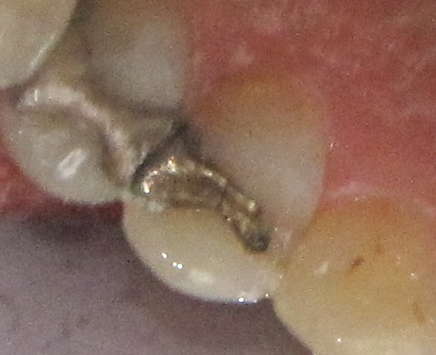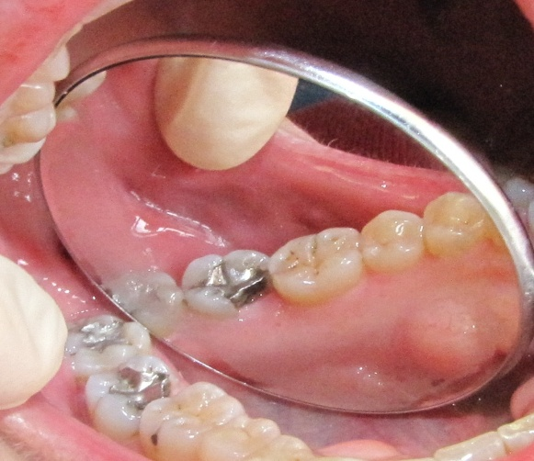

With composite restorations, over time they will show signs of discoloration from the affects of the foods that we eat and oral staining habits that we may have (e.g., smoking). They are relatively more noticeable when they discolor in comparison to amalgams, since they started out in the more ideal esthetic appearance than the look of a metal based restoration. Over time, with all the brushing and grinding we do the composite restoration does get worn down as well since we are mechanical abrading it.
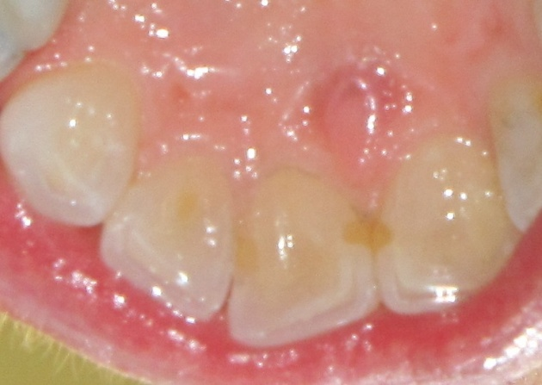

Picture of failing amalgam restoration. The margins (the junction where the restoration meets the natural tooth structure) are corroded and ditched. The teeth provide numerous retentive habitats for plaque. The corrosion and break-down at the tooth-restoration interface produces small v-shaped defects that become ne habitats for cariogenic-bacteria.
